ГОСУДАРСТВЕННОЕ ОБРАЗОВАТЕЛЬНОЕ УЧРЕЖДЕНИЕ ВЫСШЕГО ПРОФЕССИОНАЛЬНОГО ОБРАЗОВАНИЯ

ДОНЕЦКИЙ НАЦИОНАЛЬНЫЙ ТЕХНИЧЕСКИЙ УНИВЕРСИТЕТ

Лабораторная работа №3

«Контейнер базы данных(dbc).

Проектирование таблиц данных(dbf) в БД»

Выполнил:

Ст.гр. ПИ-16а

Горбань В. В.

Проверил:

Незамова Л.В.

Донецк 2017

ЭКРАННЫЕ ФОРМЫ

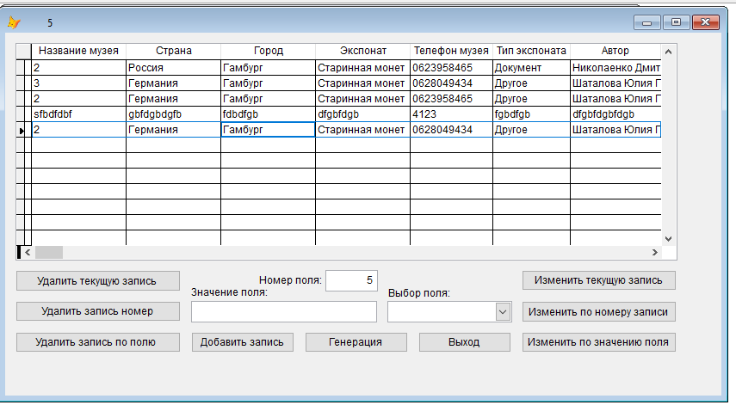

Рисунок 1- Главная форма

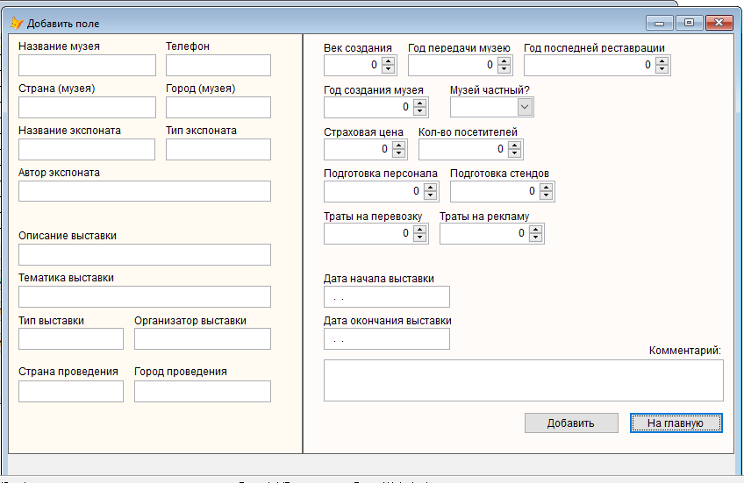

Рисунок 2 – Форма «Добавление записи»

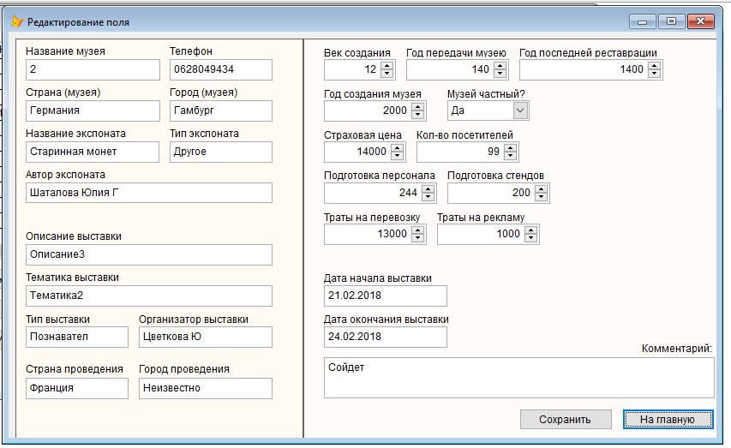

Рисунок 3 – Форма «Изменение записи»

ТЕКСТ ПРОГРАММЫ

Главная форма:

Событие загрузки формы:

GO TOP

this.Caption = STR(RECCOUNT())

Кнопка «Генерация»

\*DIMENSION arrayPrint(5) = "Печатный двор" AND "Радуга" AND "Клякса" AND "Папирус" AND "Народная печать"

\*DECLARE arrayPrint(4)

\*STORE "Печатный двор";"Радуга";"Клякса";"Папирус";"Народная печать" TO arrayPrint

Dimension arrayMuseum(5),arrayCountry(2),arrayCity(3),arrayExhibit(3),arrayPhone(4),arrayTypeExhibit(3), arrayAuthor(4)

Dimension arrayTitle(4),arrayCountryStart(3),arrayCityStart(3),arrayTypeExhibition(3)

Dimension arrayOrganizer(3),arrayAim(3)

Dimension arrayYear(4),arrayAgeCreate(3),arrayTransfer(4),arrayMoney(4),arrayRestoration(4)

Dimension arrayAccount(3),arrayInterpreters(3),arrayStand(3), arrayTransportation(3), arrayMarketing(3)

Dimension arrayDateStart(3),arrayDateFinish(3)

Dimension arrayPrivate(2)

Dimension arrayComment(4)

\*string

\*Museum

arrayMuseum[1] = "1"

arrayMuseum[2] = "2"

arrayMuseum[3] = "3"

arrayMuseum[4] = "4"

arrayMuseum[5] = "Пятый"

\*Country

arrayCountry[1] = "Россия"

arrayCountry[2] = "Германия"

\*City

arrayCity[1] = "Москва"

arrayCity[2] = "Берлин"

arrayCity[3] = "Гамбург"

\*Exhibit

arrayExhibit[1] = "Стена музея"

arrayExhibit[2] = "Птолемей"

arrayExhibit[3] = "Старинная монета"

\*Phone

arrayPhone[1] = "0623958465"

arrayPhone[2] = "0628049434"

arrayPhone[3] = "0623056165"

arrayPhone[4] = "0625474054"

\*TypeExhibit

arrayTypeExhibit[1] = "Вещественное"

arrayTypeExhibit[2] = "Документ"

arrayTypeExhibit[3] = "Другое"

\*Author

arrayAuthor[1] = "Николаенко Дмитрий Валерьевич"

arrayAuthor[2] = "Цветкова Юлия Петровна"

arrayAuthor[3] = "Шаталова Юлия Геннадиевна"

arrayAuthor[4] = "Никитюк Юрий Васильевич"

\*Title

arrayTitle[1] = "Описание1"

arrayTitle[2] = "Описание2"

arrayTitle[3] = "Описание3"

arrayTitle[4] = "Описание4"

\*CountryStart

arrayCountryStart[1] = "Россия"

arrayCountryStart[2] = "Германия"

arrayCountryStart[3] = "Франция"

\*CityStart

arrayCityStart[1] = "Петербург"

arrayCityStart[2] = "Гамбург"

arrayCityStart[3] = "Неизвестно"

\*TypeExhibition

arrayTypeExhibition[1] = "Познавательная"

arrayTypeExhibition[2] = "Развлекательная"

arrayTypeExhibition[3] = "Другая"

\*arrayOrganizer

arrayOrganizer[1] = "Николаенко Дмитрий Валерьевич"

arrayOrganizer[2] = "Цветкова Юлия Петровна"

arrayOrganizer[3] = "Никитюк Юрий Васильевич"

\*Aim

arrayAim[1] = "Тематика1"

arrayAim[2] = "Тематика2"

\*int

\*Year

arrayYear[1] = 2000

arrayYear[2] = 2001

arrayYear[3] = 2002

arrayYear[4] = 2003

\*AgeCreate

arrayAgeCreate[1] = 12

arrayAgeCreate[2] = 4

arrayAgeCreate[3] = 11

\*Transfer

arrayTransfer[1] = 100

arrayTransfer[2] = 140

arrayTransfer[3] = 150

arrayTransfer[4] = 200

\*Money

arrayMoney[1] = 10000

arrayMoney[2] = 14000

arrayMoney[3] = 15000

arrayMoney[4] = 20000

\*Restoration

arrayRestoration[1] = 1000

arrayRestoration[2] = 1400

arrayRestoration[3] = 1500

arrayRestoration[4] = 2000

\*Account

arrayAccount[1] = 123

arrayAccount[2] = 230

arrayAccount[3] = 99

\*Interpreters

arrayInterpreters[1] = 523

arrayInterpreters[2] = 244

arrayInterpreters[3] = 990

\*Stand

arrayStand[1] = 100

arrayStand[2] = 200

arrayStand[3] = 300

\*Transportation

arrayTransportation[1] = 8000

arrayTransportation[2] = 13000

arrayTransportation[3] = 12000

\*Marketing

arrayMarketing[1] = 1000

arrayMarketing[2] = 2000

arrayMarketing[3] = 3000

\*date

\*DateStart

arrayDateStart[1] = {^2018-02-20}

arrayDateStart[2] = {^2018-02-21}

arrayDateStart[3] = {^2018-02-22}

\*DateFinish

arrayDateFinish[1] = {^2018-02-23}

arrayDateFinish[2] = {^2018-02-24}

arrayDateFinish[3] = {^2018-02-25}

\*bool

\*Private

arrayPrivate[1] = .T.

arrayPrivate[2] = .F.

\*memo

\*Comment

arrayComment[1] = "Нормальный экземпляр"

arrayComment[2] = "Сойдет"

arrayComment[3] = "Достоен большего"

arrayComment[4] = "В самый раз"

For I = 1 To 2000 Step 1

\*\*\*\*\*\*\*\*\*\*\*\*\*\*\*\*\*\*\*\*\*\*\*\*\*\*\*\*\*\*\*\*\*\*\*\*\*\*\*\*\*\*\*\*\*\*\*\*\*\*\*\*\*\*\*\*\*\*\*

\*Рандомайзер

\*string

cMuseum = arrayMuseum[ROUND(4\*RAND()+1,0)]

cCountry = arrayCountry[ROUND(1\*RAND()+1,0)]

cCity = arrayCity[ROUND(2\*RAND()+1,0)]

cExhibit = arrayExhibit[ROUND(2\*RAND()+1,0)]

cPhone = arrayPhone[ROUND(3\*RAND()+1,0)]

cTypeExhibit = arrayTypeExhibit[ROUND(2\*RAND()+1,0)]

cAuthor = arrayAuthor[ROUND(3\*RAND()+1,0)]

cTitle = arrayTitle[ROUND(3\*RAND()+1,0)]

cCountryStart = arrayCountryStart[ROUND(2\*RAND()+1,0)]

cCityStart = arrayCityStart[ROUND(2\*RAND()+1,0)]

cTypeExhibition = arrayTypeExhibition[ROUND(2\*RAND()+1,0)]

cOrganizer = arrayOrganizer[ROUND(2\*RAND()+1,0)]

cAim = arrayAim[ROUND(1\*RAND()+1,0)]

\*int

cYear = arrayYear[ROUND(3\*RAND()+1,0)]

cAgeCreate = arrayAgeCreate[ROUND(2\*RAND()+1,0)]

cTransfer = arrayTransfer[ROUND(3\*RAND()+1,0)]

cMoney = arrayMoney[ROUND(3\*RAND()+1,0)]

cRestoration = arrayRestoration[ROUND(3\*RAND()+1,0)]

cAccount = arrayAccount[ROUND(2\*RAND()+1,0)]

cInterpreters = arrayInterpreters[ROUND(2\*RAND()+1,0)]

cStand = arrayStand[ROUND(2\*RAND()+1,0)]

cTransportation = arrayTransportation[ROUND(2\*RAND()+1,0)]

cMarketing = arrayMarketing[ROUND(2\*RAND()+1,0)]

\*date

cDateStart = arrayDateStart[ROUND(2\*RAND()+1,0)]

cDateFinish = arrayDateFinish[ROUND(2\*RAND()+1,0)]

\*bool

cPrivate = arrayPrivate[ROUND(1\*RAND()+1,0)]

\*memo

cComment = arrayComment[ROUND(3\*RAND()+1,0)]

\*\*\*\*\*\*\*\*\*\*\*\*\*\*\*\*\*\*\*\*\*\*\*\*\*\*\*\*\*\*\*\*\*\*\*\*\*\*\*\*\*\*\*\*\*\*\*\*\*\*\*\*\*\*\*\*\*\*\*

Insert Into Data (museum,country,city,exhibit,phone,typeexhibit,author,title,countryStart,cityStart,typeExhibition,organizer,aim,year,ageCreate,transfer,money,restoration,account,interpreters,stand,transportation,marketing,dateStart,dateFinish,private,comment);

VALUES(cMuseum,cCountry,cCity,cExhibit,cPhone,cTypeExhibit,cAuthor,cTitle,cCountryStart,cCityStart,cTypeExhibition,cOrganizer,cAim,cYear,cAgeCreate,cTransfer,cMoney,cRestoration,cAccount,cInterpreters,cStand,cTransportation,cMarketing,cDateStart,cDateFinish,cPrivate,cComment)

ENDFOR

thisform.Caption = STR(RECCOUNT())

Thisform.Grid1.Refresh

Кнопка «Добавить запись»

DO FORM addform

Кнопка «Выход»

\*закрываю таблицу

USE &&закрывание???

USE data IN 0 EXCLUSIVE &&это было открывание. Божеественно.

PACK

quit

Кнопка «Удалить Текущую запись»

GO RECNO()

DELETE

SET DELETED OFF

thisform.Caption = STR(RECCOUNT())

THISFORM.Grid1.Refresh()

Кнопка «Удалить запись номер»

SET DELETED off

SCAN

IF RECNO() = INT(THISFORM.TEXT2.Value)

DELETE

ENDIF

ENDSCAN

GO bottom

thisform.Caption = STR(RECNO())

THISFORM.Grid1.Refresh

Кнопка «Удалить запись по полю»

IF !EOF() AND !BOF()

SCAN

IF (TRIM(THISFORM.Combo2.Value) = "museum" AND data.museum=TRIM(THISFORM.text1.Text))

DELETE

ENDIF

IF (TRIM(THISFORM.Combo2.Value) = "phone" AND data.phone=TRIM(THISFORM.text1.Text))

DELETE

ENDIF

IF (TRIM(THISFORM.Combo2.Value) = "exhibit" AND data.exhibit=TRIM(THISFORM.text1.Text))

DELETE

ENDIF

IF (TRIM(THISFORM.Combo2.Value) = "typeexhibit" AND data.typeexhibit=TRIM(THISFORM.text1.Text))

DELETE

ENDIF

IF (TRIM(THISFORM.Combo2.Value) = "author" AND data.author=TRIM(THISFORM.text1.Text))

DELETE

ENDIF

IF (TRIM(THISFORM.Combo2.Value) = "organizer" AND data.organizer=TRIM(THISFORM.text1.Text))

DELETE

ENDIF

ENDSCAN

SET DELETED OFF

thisform.Caption = STR(RECCOUNT())

THISFORM.Grid1.Refresh()

ENDIF

Кнопка «Изменить текущую запись»

IF !EOF() AND !BOF() THEN

DO FORM editform WITH "0" TO cRecordNumber

ENDIF

Кнопка «Изменить запись по номеру»

IF !EOF() AND !BOF()

SCAN

IF RECNO() = INT(THISFORM.TEXT2.Value)

DO FORM editform WITH "1", INT(THISFORM.TEXT2.Value)

ENDIF

ENDSCAN

ENDIF

Кнопка «Удалить по полю»

IF !EOF() AND !BOF()

SCAN

IF (TRIM(THISFORM.Combo2.Value) = "museum" AND data.museum=TRIM(THISFORM.text1.Text))

DO FORM editform WITH "0" TO cRecordNumber

ENDIF

IF (TRIM(THISFORM.Combo2.Value) = "phone" AND data.phone=TRIM(THISFORM.text1.Text))

DO FORM editform WITH "0" TO cRecordNumber

ENDIF

IF (TRIM(THISFORM.Combo2.Value) = "exhibit" AND data.exhibit=TRIM(THISFORM.text1.Text))

DO FORM editform WITH "0" TO cRecordNumber

ENDIF

IF (TRIM(THISFORM.Combo2.Value) = "typeexhibit" AND data.typeexhibit=TRIM(THISFORM.text1.Text))

DO FORM editform WITH "0" TO cRecordNumber

ENDIF

IF (TRIM(THISFORM.Combo2.Value) = "author" AND data.author=TRIM(THISFORM.text1.Text))

DO FORM editform WITH "0" TO cRecordNumber

ENDIF

IF (TRIM(THISFORM.Combo2.Value) = "organizer" AND data.organizer=TRIM(THISFORM.text1.Text))

DO FORM editform WITH "0" TO cRecordNumber

ENDIF

ENDSCAN

SET DELETED OFF

GO TOP

thisform.Caption = STR(RECCOUNT())

THISFORM.GRid1.Refresh()

ENDIF

Окно изменения:

Событие загрузки формы:

LPARAMETERS cRecordNumber1,cRecordNumber12

IF cRecordNumber1 = "0"

GO (Recno())

\*string

Thisform.Text1.Value = data.museum

Thisform.Text2.Value = data.country

Thisform.Text24.Value = data.city

Thisform.Text3.Value = data.exhibit

Thisform.Text5.Value = data.phone

Thisform.Text23.Value = data.typeexhibit

Thisform.Text4.Value = data.author

Thisform.Text6.Value = data.title

Thisform.Text10.Value = data.countrystart

Thisform.Text11.Value = data.citystart

Thisform.Text8.Value = data.typeexhibition

Thisform.Text9.Value = data.organizer

Thisform.Text7.Value = data.aim

\*int

Thisform.spinner1.Value = data.year

Thisform.spinner2.Value = data.agecreate

Thisform.spinner3.Value = data.transfer

Thisform.spinner4.Value = data.money

Thisform.spinner5.Value = data.restoration

Thisform.spinner6.Value = data.account

Thisform.spinner7.Value = data.interpreters

Thisform.spinner9.Value = data.stand

Thisform.spinner8.Value = data.transportation

Thisform.spinner10.Value = data.marketing

\*date

Thisform.text20.Value = data.datestart

Thisform.text21.Value = data.datefinish

\*bool

cPrivate = data.private

If cPrivate = .T. Then

thisform.combo1.value = "Да"

ELSE

thisform.combo1.Value = "Нет"

Endif

\*memo

Thisform.text22.Value = data.comment

ENDIF

IF cRecordNumber1 = "1" AND cRecordNumber12<=RECCOUNT()

GO (cRecordNumber12)

\*string

Thisform.Text1.Value = data.museum

Thisform.Text2.Value = data.country

Thisform.Text24.Value = data.city

Thisform.Text3.Value = data.exhibit

Thisform.Text5.Value = data.phone

Thisform.Text23.Value = data.typeexhibit

Thisform.Text4.Value = data.author

Thisform.Text6.Value = data.title

Thisform.Text10.Value = data.countrystart

Thisform.Text11.Value = data.citystart

Thisform.Text8.Value = data.typeexhibition

Thisform.Text9.Value = data.organizer

Thisform.Text7.Value = data.aim

\*int

Thisform.spinner1.Value = data.year

Thisform.spinner2.Value = data.agecreate

Thisform.spinner3.Value = data.transfer

Thisform.spinner4.Value = data.money

Thisform.spinner5.Value = data.restoration

Thisform.spinner6.Value = data.account

Thisform.spinner7.Value = data.interpreters

Thisform.spinner9.Value = data.stand

Thisform.spinner8.Value = data.transportation

Thisform.spinner10.Value = data.marketing

\*date

Thisform.text20.Value = data.datestart

Thisform.text21.Value = data.datefinish

\*bool

cPrivate = data.private

If cPrivate = .T. Then

thisform.combo1.value = "Да"

ELSE

thisform.combo1.Value = "Нет"

Endif

\*memo

Thisform.text22.Value = data.comment

ENDIF

Кнопка «Сохранить»

\*объявление и инициализация переменных

\*string

cMuseum = Thisform.Text1.Value

cCountry = Thisform.Text2.Value

cCity = Thisform.Text24.Value

cExhibit = Thisform.Text3.Value

cPhone = Thisform.Text5.Value

cTypeExhibit = Thisform.Text23.Value

cAuthor = Thisform.Text4.Value

cTitle = Thisform.Text6.Value

cCountryStart = Thisform.Text10.Value

cCityStart = Thisform.Text11.Value

cTypeExhibition = Thisform.Text8.Value

cOrganizer = Thisform.Text9.Value

cAim = Thisform.Text7.Value

\*int

cYear = Thisform.spinner1.Value

cAgeCreate = Thisform.spinner2.Value

cTransfer = Thisform.spinner8.Value

cMoney = Thisform.spinner4.Value

cRestoration = Thisform.spinner5.Value

cAccount = Thisform.spinner6.Value

cInterpreters = Thisform.spinner7.Value

cStand = Thisform.spinner9.Value

cTransportation = Thisform.spinner8.Value

cMarketing = Thisform.spinner10.Value

\*date

cDateStart = Thisform.text20.Value

cDateFinish = Thisform.text21.Value

\*bool

cPrivate = .F.

If Thisform.combo1.Value = "Да" Then

cPrivate = .T.

Endif

\*memo

cComment = Thisform.text22.Value

\*Замена

Replace museum With cMuseum ;

country With cCountry;

city With cCity ;

exhibit With cExhibit ;

phone With cPhone ;

typeexhibit With cTypeExhibit;

author With cAuthor;

title With cTitle;

countrystart With cCountryStart;

citystart With cCityStart;

typeexhibition With cTypeExhibition;

organizer With cOrganizer ;

aim With cAim ;

year With cYear;

agecreate With cAgeCreate ;

transfer With cTransfer ;

money With cMoney ;

restoration With cRestoration ;

account With cAccount ;

interpreters With cInterpreters ;

stand With cStand ;

transportation With cTransportation;

marketing With cMarketing ;

datestart With cDateStart;

datefinish With cDateFinish;

private With cPrivate;

comment With cComment;

Messagebox("Сохранено",0)

Форма добавления

Кнопка «Добавить»

\*объявление и инициализация переменных

\*string

cMuseum = THISFORM.Text1.Value

cCountry = THISFORM.Text2.Value

cCity = THISFORM.Text24.Value

cExhibit = THISFORM.Text3.Value

cPhone = THISFORM.Text5.Value

cTypeExhibit = THISFORM.Text23.Value

cAuthor = THISFORM.Text4.Value

cTitle = THISFORM.Text6.Value

cCountryStart = THISFORM.Text10.Value

cCityStart = THISFORM.Text11.Value

cTypeExhibition = THISFORM.Text8.Value

cOrganizer = THISFORM.Text9.Value

cAim = THISFORM.Text7.Value

\*int

cYear = THISFORM.spinner1.Value

cAgeCreate = THISFORM.spinner2.Value

cTransfer = THISFORM.spinner8.Value

cMoney = THISFORM.spinner4.Value

cRestoration = THISFORM.spinner5.Value

cAccount = THISFORM.spinner6.Value

cInterpreters = THISFORM.spinner7.Value

cStand = THISFORM.spinner9.Value

cTransportation = THISFORM.spinner8.Value

cMarketing = THISFORM.spinner10.Value

\*date

cDateStart = thisForm.text20.Value

cDateFinish = thisForm.text21.Value

\*bool

cPrivate = .F.

if thisForm.combo1.Value = "Да" then

cPrivate = .T.

endif

\*memo

cComment = thisForm.text22.Value

\*Добавление в таблицу данных

INSERT INTO data (museum, country, city, exhibit, phone, typeexhibit, author, title, countrystart, citystart, typeexhibition, organizer, aim, year, agecreate, transfer, money, restoration, account, interpreters, stand, transportation, marketing, datestart, datefinish, private, comment);

VALUES(cMuseum, cCountry, cCity, cExhibit, cPhone, cTypeExhibit, cAuthor, cTitle, cCountryStart, cCityStart, cTypeexhibition, cOrganizer, cAim, cYear, cAgecreate, cTransfer, cMoney, cRestoration, cAccount, cInterpreters, cStand, cTransportation, cMarketing, cDateStart, cDateFinish, cPrivate, cComment)

MESSAGEBOX("Запись добавлена!",0)